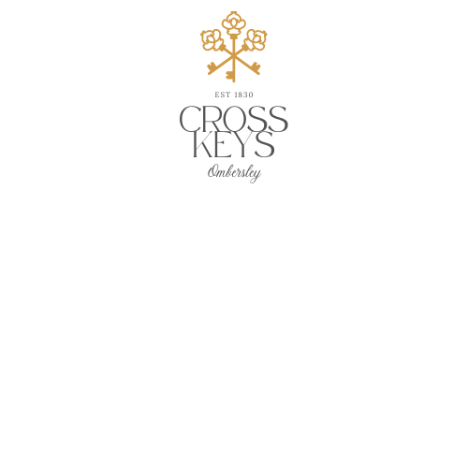 

***Sandwiches***

**available Tuesday to Saturday lunchtimes 12 – 2:30pm**

served on toasted ciabatta or thick granary bread

with dressed salad leaves

& either stick fries **OR** a bowl of today’s soup

**Roast Chicken + Smoked Bacon + Mayo + Rocket**

**~**

**Scottish Smoked Salmon + Rocket + Lemon Mayonnaise**

**~**

**Crayfish & Prawn Cocktail + Marie Rose Sauce**

**~**

**Battered Fishfingers + Tartare Sauce**

**~**

**Roast Beef + Horseradish + Jus**

**all £9.50**

**‘Keys’ Steak Ciabatta...£14**

***served medium rare or well done***

**6oz Ribeye + Red Onion Jam + Mayo + Rocket**

***Sandwiches***

**available Tuesday to Saturday lunchtimes 12 – 2:30pm**

served on toasted ciabatta or thick granary bread

with dressed salad leaves

& either stick fries **OR** a bowl of today’s soup

**Roast Chicken + Smoked Bacon + Mayo + Rocket**

**~**

**Scottish Smoked Salmon + Rocket + Lemon Mayonnaise**

**~**

**Crayfish & Prawn Cocktail + Marie Rose Sauce**

**~**

**Battered Fishfingers + Tartare Sauce**

**~**

**Roast Beef + Horseradish +Jus**

**all £9.50**

**‘Keys’ Steak Ciabatta...£14**

***served medium rare or well done***

**6oz Ribeye + Red Onion Jam + Mayo + Rocket**

Cross Keys, Main Road,

Ombersley, Nr Droitwich,

Worcestershire, WR9 0DS

Telephone 01905 885288 [www.cross](http://www.cross)keysombersley.com

Cross Keys, Main Road,

Ombersley, Nr Droitwich,

Worcestershire, WR9 0DS

Telephone 01905 885288 [www.cross](http://www.cross)keysombersley.com